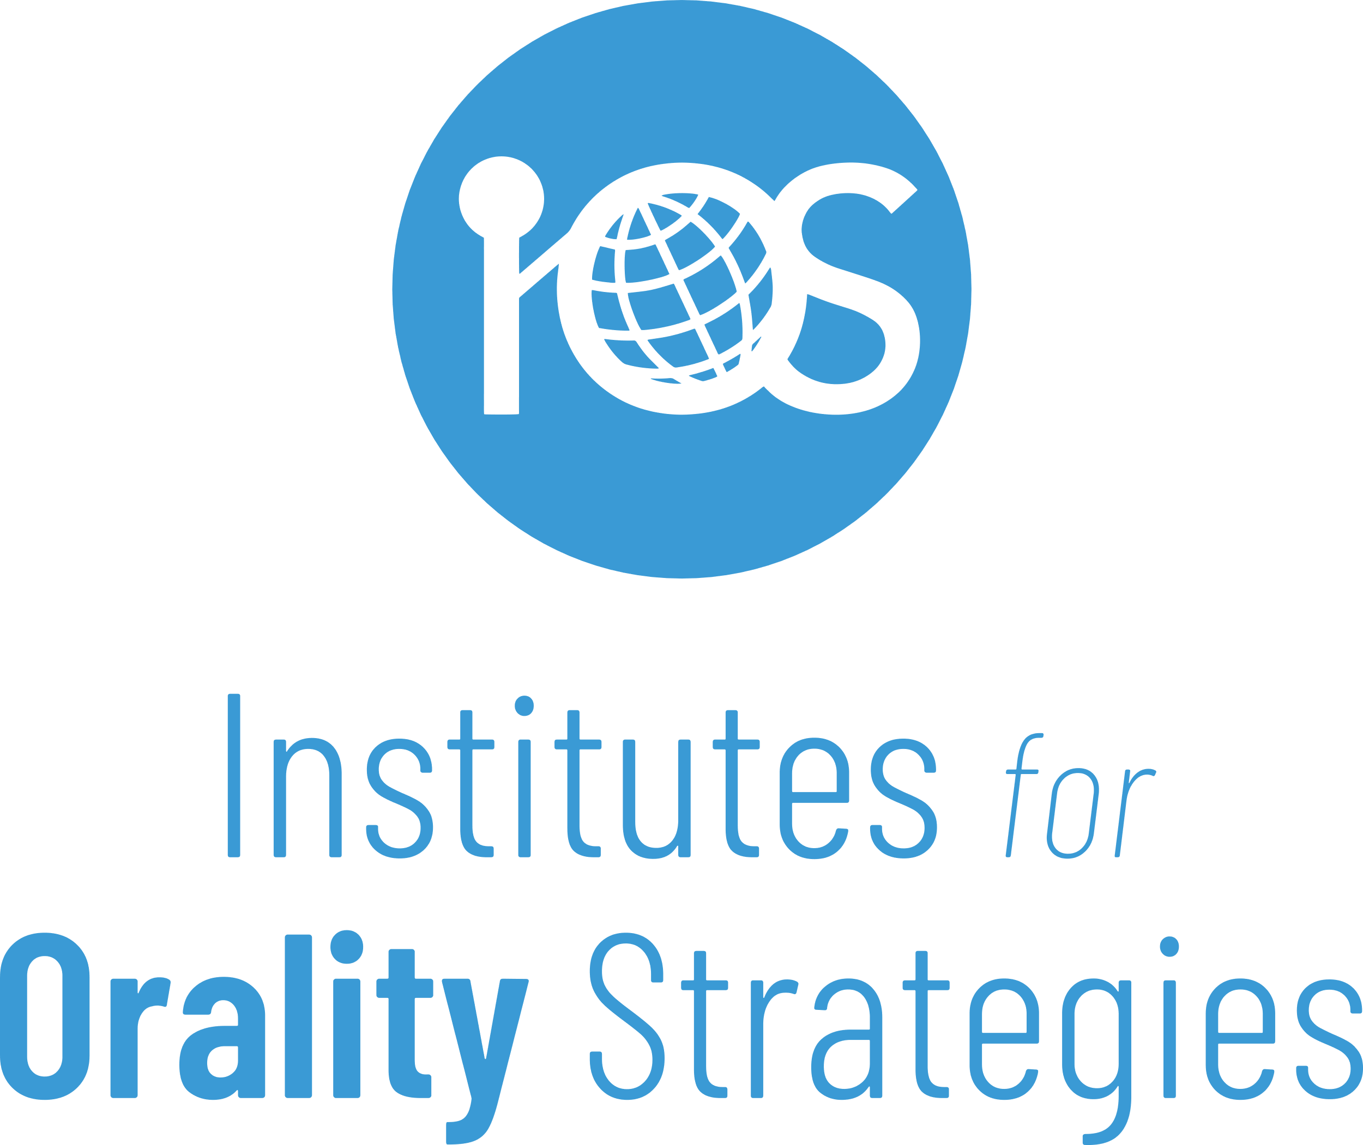

in partnership with



application form* for the course

MASTER OF ARTS

**Orality Studies Concentration**

|  |  |  |
| --- | --- | --- |
| **Applicants’ general information** | | Click or tap the icon to add your photo. |
| Full Name: | Click or tap here to enter text. |
| Email: | Click or tap here to enter text. |
| Phone: | Click or tap here to enter text. |
| Address: | Click or tap here to enter text. |
| Country: | Click or tap here to enter text. |
| Church / Mission: | Click or tap here to enter text. |
| Work / Ministry: | Click or tap here to enter text. |
|  | Inform me about scholarship options. |

Provide **two references** who can attest to your qualifications and character: one should be a **representative from your church** (such as a pastor or elder), and the other an **academic reference** from the institution where you obtained your BA (such as a professor or advisor).

|  |  |  |  |
| --- | --- | --- | --- |
| **Church reference** | | **Academic reference** | |
| Name: | Click or tap here to enter text. | Name: | Click or tap here to enter text. |
| Email: | Click or tap here to enter text. | Email: | Click or tap here to enter text. |
| Phone: | Click or tap here to enter text. | Phone: | Click or tap here to enter text. |

*Once accepted, you will be asked to complete the enrollment form for Kairos University.

Please answer the questions below so we can get to know you better.

Answer two questions of your choice in essay form (2-3 paragraphs each) and the remaining two questions in **video or a creative artistic form of your preference**.

You can use the space provided to answer the essay questions and attach the other two as separate files to the email.

|  |
| --- |
| **Tell us the story about your journey to and with Christ.** |
| Click or tap here to enter text. |

|  |
| --- |
| **What people influenced your journey? How (be specific)?** |
| Click or tap here to enter text. |

|  |
| --- |
| **What is your understanding of orality?** |
| Click or tap here to enter text. |

|  |
| --- |
| **How do you expect this program to impact your ministry?** |
| Click or tap here to enter text. |

Email this completed form to [training@i-os.org](mailto:training@i-os.org).

**Attach all supporting files** and your **BA transcript of records** with a GPA of 2.5 or higher.